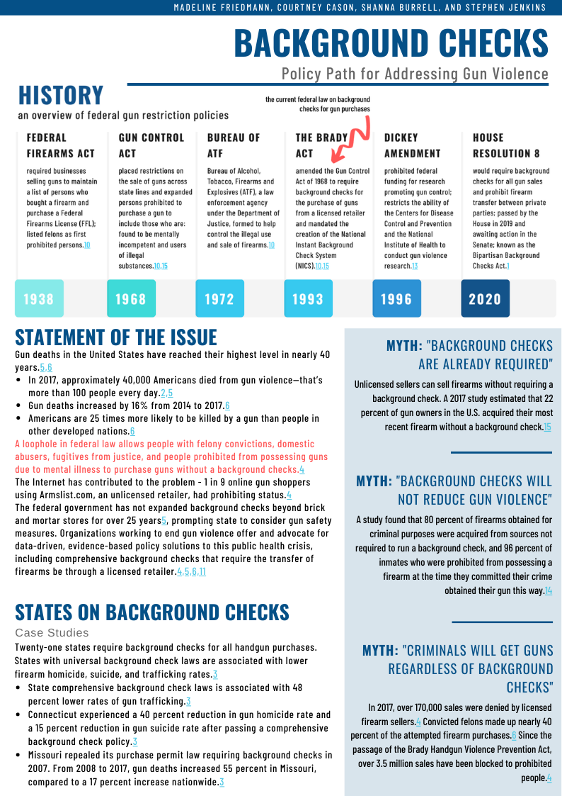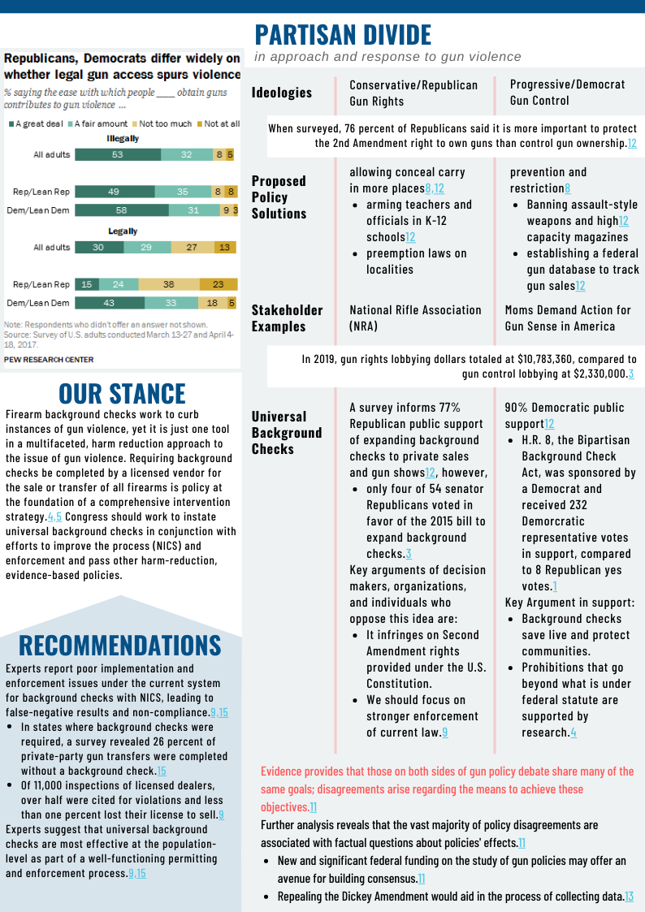
Courtney Cason

References
- Bipartisan Background Checks Act, H.R. 8, 116th Cong. (2019)
- Chipman, D. (2020, February 21). Background Checks Myths, Debunked. Giffords Law Center. https://giffords.org/blog/2020/02/background-checks-myths-debunked/
- Center for Responsive Politics. (n.d.). Gun rights vs. gun control. OpenSecrets. http://www.opensecrets.org/news/issues/guns
- Everytown for Gun Safety. (2019, January 8). Background Checks Save Lives and Protect Our Communities [Fact sheet]. Retrieved from https://everytownresearch.org/wp-content/uploads/2019/01/2019-Background-Checks-Fact-Sheet-2-1.pdf
- Everytown for Gun Safety. (2020). Better background checks. Everytown for Gun Safety. https://everytown.org/issue/background-checks/.
- Giffords Law Center. (2020). Gun violence statistics. Giffords Law Center. https://lawcenter.giffords.org/facts/gun-violence-statistics/
- Gray, S. (2019, April 30). A timeline of gun control laws in the U.S. TIME. https://time.com/5169210/us-gun-control-laws-history-timeline/
- Igielnik, R. & Brown, A. (2017, June 22). Key takeaways on Americans’ views of guns and gun ownership. Pew Research Center. https://www.pewresearch.org/fact- tank/2017/06/22/key-takeaways-on-americans-views-of-guns-and-gun-ownership/
- Lopez, G. (2019, February 6.) Democrats need to think way bigger on guns. VOX. https://www.vox.com/future-perfect/2019/1/9/18171909/universal-background-checks-hr-8-gun-violence-democrats
- Miller, B. (2019, May 30). The history of gun background checks. Foundation for Economic Education. https://fee.org/articles/the-history-of-gun-background-checks/
- Morral, A. R., Schnell, T. L., & Tankard, M. (2018). The magnitude and sources of disagreement among gun policy experts. RAND Corporation. Retrieved March 13, 2020, from https://www.rand.org/pubs/research_reports/RR2088z1.html
- Parker, K., Horowitz, J. M., Igielnik, R., Oliphant, B. J., & Brown, A. (2017, June 22). America’s complex relationship with guns: Views on gun policy. Pew Research Center. https://www.pewsocialtrends.org/2017/06/22/views-on-gun-policy/
- Rostron, A. (2018). The Dickey Amendment on federal funding for research on gun violence: A legal dissection. American Journal of Public Health, 108(7), 865-867. https://doi.org/10.2105/AJPH.2018.304450
- Vittes, K. A., Vernick, J. S., & Webster, D. W. (2013). Firearm Acquisition Without Background Check: Results of a National Survey. Injury Prevention, (19), 26-31. doi:10.1136/injuryprev-2011-040290
- Wintemute, G. J. (2019). Background checks for firearm purchases: problem areas and recommendations to improve effectiveness. Health Affairs, 38(10), 1702-1710. doi:10.1377/hlthaff.2019.00671

