Additional Exam 2 Practice Problems
(Answers are in the textbook at the end of the chapter)
Chapter 8:
95. Among various ethnic groups, the standard deviation of heights is known to be approximately three inches. We wish to construct a 95% confidence interval for the mean height of male Swedes. Forty-eight male Swedes are surveyed. The sample mean is 71 inches. The sample standard deviation is 2.8 inches.

  - x¯ =________
  - σ =________
  - n =________
- In words, define the random variables X and X¯¯¯.
- Which distribution should you use for this problem? Explain your choice.
- Construct a 95% confidence interval for the population mean height of male Swedes.
  - State the confidence interval.
  - Sketch the graph.
  - Calculate the error bound.
97. Suppose that an accounting firm does a study to determine the time needed to complete one person’s tax forms. It randomly surveys 100 people. The sample mean is 23.6 hours. There is a known standard deviation of 7.0 hours. The population distribution is assumed to be normal.

  - x¯ =________
  - σ =________
  - n =________
- In words, define the random variables X and X¯¯¯.
- Which distribution should you use for this problem? Explain your choice.
- Construct a 90% confidence interval for the population mean time to complete the tax forms.
  - State the confidence interval.
  - Sketch the graph.
  - Calculate the error bound.
99. A camp director is interested in the mean number of letters each child sends during his or her camp session. The population standard deviation is known to be 2.5. A survey of 20 campers is taken. The mean from the sample is 7.9 with a sample standard deviation of 2.8.

  - x¯ =________
  - σ =________
  - n =________
- Define the random variables X and X¯¯¯ in words.
- Which distribution should you use for this problem? Explain your choice.
- Construct a 90% confidence interval for the population mean number of letters campers send home.
  - State the confidence interval.
  - Sketch the graph.
  - Calculate the error bound.
105. A random survey of enrollment at 35 community colleges across the United States yielded the following figures: 6,414; 1,550; 2,109; 9,350; 21,828; 4,300; 5,944; 5,722; 2,825; 2,044; 5,481; 5,200; 5,853; 2,750; 10,012; 6,357; 27,000; 9,414; 7,681; 3,200; 17,500; 9,200; 7,380; 18,314; 6,557; 13,713; 17,768; 7,493; 2,771; 2,861; 1,263; 7,285; 28,165; 5,080; 11,622. Assume the underlying population is normal.

  - x¯ = __________
  - sx = __________
  - n = __________
  - n – 1 = __________
- Define the random variables X and X¯¯¯ in words.
- Which distribution should you use for this problem? Explain your choice.
- Construct a 95% confidence interval for the population mean enrollment at community colleges in the United States.
  - State the confidence interval.
  - Sketch the graph.
  - Calculate the error bound.
107. A pharmaceutical company makes tranquilizers. It is assumed that the distribution for the length of time they last is approximately normal. Researchers in a hospital used the drug on a random sample of nine patients. The effective period of the tranquilizer for each patient (in hours) was as follows: 2.7; 2.8; 3.0; 2.3; 2.3; 2.2; 2.8; 2.1; and 2.4.

  - x¯ = __________
  - sx = __________
  - n = __________
  - n – 1 = __________
- Define the random variable X in words.
- Define the random variable X¯¯¯ in words.
- Which distribution should you use for this problem? Explain your choice.
- Construct a 95% confidence interval for the population mean length of time.
  - State the confidence interval.
  - Sketch the graph.
  - Calculate the error bound.
- What does it mean to be “95% confident” in this problem?
Chapter 9:
62. Some of the following statements refer to the null hypothesis, some to the alternate hypothesis.
State the null hypothesis, H₀, and the alternative hypothesis. H_{a}, in terms of the appropriate parameter (μ or p).
- The mean number of years Americans work before retiring is 34.
- At most 60% of Americans vote in presidential elections.
- The mean starting salary for San Jose State University graduates is at least $100,000 per year.
- Twenty-nine percent of high school seniors get drunk each month.
- Fewer than 5% of adults ride the bus to work in Los Angeles.
- The mean number of cars a person owns in her lifetime is not more than ten.
- About half of Americans prefer to live away from cities, given the choice.
- Europeans have a mean paid vacation each year of six weeks.
- The chance of developing breast cancer is under 11% for women.
- Private universities' mean tuition cost is more than $20,000 per year.
64. A statistics instructor believes that fewer than 20% of Evergreen Valley College (EVC) students attended the opening night midnight showing of the latest Harry Potter movie. She surveys 84 of her students and finds that 11 attended the midnight showing. An appropriate alternative hypothesis is:
- p = 0.20
- p > 0.20
- p < 0.20
- p ≤ 0.20
68. When a new drug is created, the pharmaceutical company must subject it to testing before receiving the necessary permission from the Food and Drug Administration (FDA) to market the drug. Suppose the null hypothesis is “the drug is unsafe.” What is the Type II Error?
- To conclude the drug is safe when in, fact, it is unsafe.
- Not to conclude the drug is safe when, in fact, it is safe.
- To conclude the drug is safe when, in fact, it is safe.
- Not to conclude the drug is unsafe when, in fact, it is unsafe.

Chapter 10:

79. A student at a four-year college claims that mean enrollment at four–year colleges is higher than at two–year colleges in the United States. Two surveys are conducted. Of the 35 two–year colleges surveyed, the mean enrollment was 5,068 with a standard deviation of 4,777. Of the 35 four-year colleges surveyed, the mean enrollment was 5,466 with a standard deviation of 8,191.

- H₀: _______
- H_{a}: _______
- State the distribution to use for the test.
- What is the test statistic?
- What is the p-value? In one to two complete sentences, explain what the p-value means for this problem.
- Use the previous information to sketch a picture of this situation. CLEARLY label and scale the horizontal axis and shade the region(s) corresponding to the p-value.
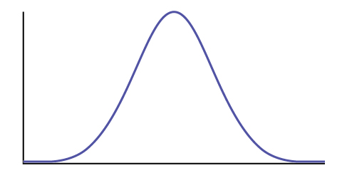
- Indicate the correct decision (“reject” or “do not reject” the null hypothesis), the reason for it, and write an appropriate conclusion, using complete sentences.
  - Alpha: _______
  - Decision: _______
  - Reason for decision: _______
  - Conclusion: _______
- In complete sentences, explain how you determined which distribution to use.

94. Parents of teenage boys often complain that auto insurance costs more, on average, for teenage boys than for teenage girls. A group of concerned parents examines a random sample of insurance bills. The mean annual cost for 36 teenage boys was $679. For 23 teenage girls, it was $559. From past years, it is known that the population standard deviation for each group is $180. Determine whether or not you believe that the mean cost for auto insurance for teenage boys is greater than that for teenage girls.

- H₀: _______
- H_{a}: _______
- State the distribution to use for the test.
- What is the test statistic?
- What is the p-value? In one to two complete sentences, explain what the p-value means for this problem.
- Use the previous information to sketch a picture of this situation. CLEARLY label and scale the horizontal axis and shade the region(s) corresponding to the p-value.
- Indicate the correct decision (“reject” or “do not reject” the null hypothesis), the reason for it, and write an appropriate conclusion, using complete sentences.
  - Alpha: _______
  - Decision: _______
  - Reason for decision: _______
  - Conclusion: _______
- In complete sentences, explain how you determined which distribution to use.

Chapter 11:

75. Perform a goodness-of-fit test to determine whether the local results follow the distribution of U.S. AP examinee population, based on ethnicity.

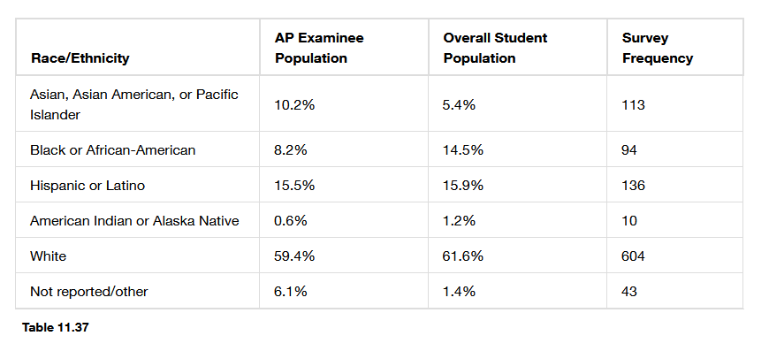
- H₀: _______
- H_{a}: _______
- What are the degrees of freedom?
- State the distribution to use for the test.
- What is the test statistic?
- What is the p-value? In one to two complete sentences, explain what the p-value means for this problem.
- Use the previous information to sketch a picture of this situation. Clearly label and scale the horizontal axis and shade the region(s) corresponding to the p-value.
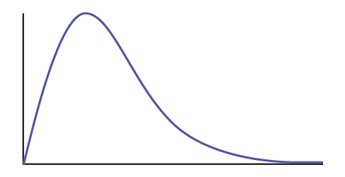
Figure E4
- Indicate the correct decision (“reject” or “do not reject” the null hypothesis) and write appropriate conclusions, using complete sentences.
  - Alpha: _______
  - Decision: _______
  - Reason for decision: _______
  - Conclusion: _______

77. Conduct a goodness-of-fit test to determine if the actual college majors of graduating females fit the distribution of their expected majors.
Major | Women - Expected Major | Women - Actual Major
Arts & Humanities | 14.0% | 670
Biological Sciences | 8.4% | 410
Business | 13.1% | 685
Education | 13.0% | 650
Engineering | 2.6% | 145
Physical Sciences | 2.6% | 125
Professional | 18.9% | 975
Social Sciences | 13.0% | 605
Technical | 0.4% | 15
Other | 5.8% | 300
Undecided | 8.0% | 420
Table 11.39

- H₀: _______
- H_{a}: _______
- What are the degrees of freedom?
- State the distribution to use for the test.
- What is the test statistic?
- What is the p-value? In one to two complete sentences, explain what the p-value means for this problem.
- Use the previous information to sketch a picture of this situation. Clearly label and scale the horizontal axis and shade the region(s) corresponding to the p-value.
Figure E4
- Indicate the correct decision (“reject” or “do not reject” the null hypothesis) and write appropriate conclusions, using complete sentences.
  - Alpha: _______
  - Decision: _______
  - Reason for decision: _______
  - Conclusion: _______
101. A psychologist is interested in testing whether there is a difference in the distribution of personality types for business majors and social science majors. The results of the study are shown in Table 11.54. Conduct a test of homogeneity. Test at a 5% level of significance.
 | Open | Conscientious | Extrovert | Agreeable | Neurotic
Business | 41 | 52 | 46 | 61 | 58
Social Science | 72 | 75 | 63 | 80 | 65

Table 11.54

- H₀: _______
- H_{a}: _______
- What are the degrees of freedom?
- State the distribution to use for the test.
- What is the test statistic?
- What is the p-value? In one to two complete sentences, explain what the p-value means for this problem.
- Use the previous information to sketch a picture of this situation. Clearly label and scale the horizontal axis and shade the region(s) corresponding to the p-value.
Figure E4
- Indicate the correct decision (“reject” or “do not reject” the null hypothesis) and write appropriate conclusions, using complete sentences.
  - Alpha: _______
  - Decision: _______
  - Reason for decision: _______
  - Conclusion: _______

