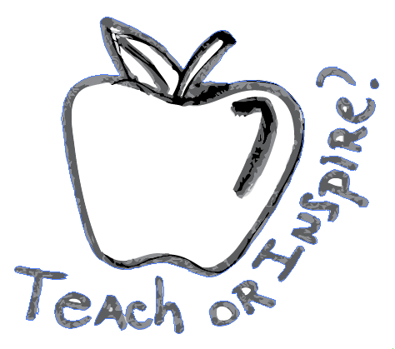
My Art Education Philosophy

"Art education is about individuals and their growth in understanding the world they live in through the work of artists. It is about communication with others, telling personal stories, and revealing values and beliefs through creative work with art media and through interpretive work with the artworks of students and professionals” (Gerber & Guay, Reaching and Teaching, Students with Special Needs through Art.2014, p. 8)

Art reaches students of all ages, skills, and abilities levels. Well directed every student will find at least one medium and a style that they like. After that, there are so many things that they learn through art: how to express themselves to the world, achieve high thinking levels, problem-solving behavior, and the importance of mutual respect when confronting different points of view. These beliefs strongly influence my philosophy of education.
"What is art?" is a millenary trick question, and it has a simple role: to keep art around. While nobody finds the answer, everybody still thinks about it. And to me, that is what art is all about "to make us think." As an art teacher, I aim to stimulate my students to be critical thinkers and risk takers, learn art skills and artistic behavior, and become happy, persevering people. To help my students accomplish that, I use all the tools and strategies I can. The experimentation in my teaching style is as necessary as the building skill lessons based on a more traditional school approach.
I build on my students' skills; at the same time, I encourage them to be the directors of their art, hoping that through this practice, they will learn to be the directors of their own lives.
Willing to deliver skills and experimentation, I rely on the traditional school methods, where I can count on direct and didactic strategies like positive reinforcements, a fixed routine, and a more controlled environment to transmit instructions and teach basic skills to all the students. My primary goal is to reach many students possible in the first moment with the skill-building lessons and to individualize the process and the growth the most during the studio time.
After delivering skills' building instructions, the didactic is student-focused. The learning is discovery-based, with a progressivism approach, making it possible for the students to develop their projects by applying the skill they want to improve at that time. Through experimentation and social experiences, other skills will be formed naturally, individually and as a group.
The environment of my classroom is held by equality and equity. Where all should feel welcome and comfortable to live their authentic selves. As an art teacher, I am committed to providing my students with the best tools and knowledge. I want to ensure they will achieve their full potential as artists and human beings.
In my art room, I want students to experiment in a safe space, so they can express themselves in the best honest and risk-taking way. When looking around, we need to see what others are with no criticism, engaging in our differences as a way to explore, learn, and grow while using our similarities to create community.
Not being afraid of who is different from us is the first step to knowing and respecting that one and the others like that.
Once my teaching style is mostly based on TAB (Teaching Artistic Behavior), a choice-based education, my lessons have strong influences by John Dewey's Progressivism Philosophy. In the individualized portion of the class, I am influenced by Humanism. However, I also like to use techniques and tools from the Essentialism and Behaviorism Philosophies, mainly in the demonstration and skill-building lessons.
Considering all the different skills and abilities present in the art room, providing a place where each student is comfortable and able to create is the Humanism spectrum of my teaching style. Once each student chooses their process and project to work on, the content that will be learned will be particular according to that individual process and experience.

